DATE: 21.09.2018
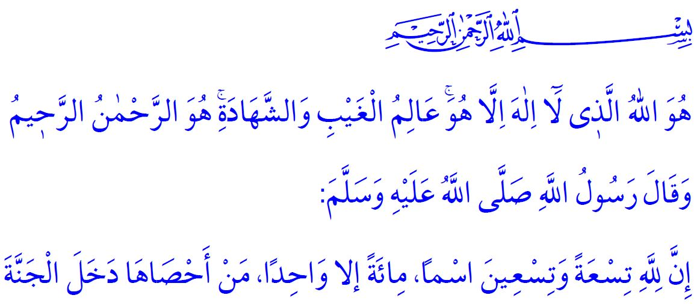
MESSAGES TO BELIEVERS FROM THE BEAUTIFUL NAMES OF ALLAH
Esteemed Believers!
We as Muslims recite the last three verses of the Surah al-Hashr after the fajr (morning) and maghrib (evening) prayers. We think of the existence, oneness, and exaltedness of Allah (swt), and glorify Him with His Asma al-Husna (the Most Beautiful Names). We seek to become the beneficiaries of the Prophet’s (saw) glad tiding that angels will pray for those who recite these verses in the morning and in the evening.
Valuable Muslims!
The last three verses of the Surah al-Hashr starts with the precept of oneness of Allah that reads as, 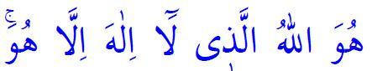 “He is Allah, other than Whom there is no deity”. It teaches every human being that they need to acknowledge this truth by heart and be sincerely devoted to Allah (swt).
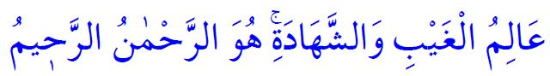 Our Lord knows all things, visible or invisible. He is al-Rahman, most merciful for all people in the world. He is al-Rahim, especially merciful for the believers in the Hereafter.
Believers live their life knowing that Allah (swt) sees them at any time and at any place, and knows their all intentions as we believers acknowledge that our Lord is closer to us than our jugular vein
Esteemed Brothers and Sisters!
Allah (swt) introduces Himself to us with His names as follows: Our Lord is al-Malik, the Only Owner of Sovereignty. To him belongs existence and non-existence. It is He who entrusts all the blessings in our possession. Believers live their life with the awareness that every blessing in their possession is entrusted to them by Allah (swt). They do not fall captive to possessions, high ranks or positions, and fortune or fame. On the contrary, they believe that they will account for all blessings they have had, so they observe and respect the entrusted blessings.
Allah the Almighty (swt) is al Quddus, far from any kind of deficiency. He has the absolute perfection. He is al-Salam, the Source of Peace. Believers, therefore, seek to establish peace and quiet particularly in their family, and in any area of their life as well.
Allah the Almighty (swt) is al Mu’min, the Giver of Security and the Preserver of Safety. He is the Bestower of Faith for those who open their hearts. He is al-Muhaymin, the Guardian of Faith and the Overseer of all things. In the face of all worldly troubles, He (swt) is Whom we depend, seek refuge in, beg and pray with our hands open for.
He is al-Aziz, the only Victorious, the Real Owner of glory and fame. He is al-Jabbar, the One Who performs what He wills in every situation, heals the wounds and grieves the troubles. He is al-Mutakabbir; greatness suits only Him; He has no match in greatness. Everyone is helpless and incapable before Him. 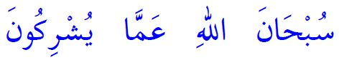 Our Lord (swt) is free from any kind of imperfection, He has no match or counterpart.
Honorable Muslims!
In the last verse of Surah al-Hashr, our Almighty Lord (swt) states: 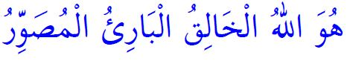 Allah (swt) is He Who creates what He wills in the form He wills uniquely without an example. He (swt) determines the shapes and characteristics of creatures. Believers look out for their disposition bestowed by their Lord until their last breath. They know that the valuable thing in the presence of Allah (swt) is not appearance, wealth or property but a perfect faith, a kind heart, righteous deeds and good morality. They protect their heart from the evil such as grudge, hatred, corruption, and envy.
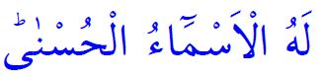 The most beautiful names belong to Him (swt). We supplicate Allah (swt) with His most beautiful names. Our Prophet (saw) said, “Allah has ninety-nine names. Whoever learns them and counts by acting accordingly will go to Paradise.”. Comprehending the meaning of our Lord’s Asma al-Husna and acting accordingly must be our purpose.
Whatever is in the heavens and on earth all exalt and glorify Allah (swt). To Him (swt) belongs the absolute power, judgement, and wisdom. Our duty is to glorify our Almighty Lord and to submit to Him with both our words and attitudes in compliance with His consent.
Esteemed Brothers and Sisters!
The necessity of faith in Allah is not associating anything with Him (swt), and not bowing down before any other power. It is never to neglect the duties of servitude which are the indicators of submission to Allah (swt).
Let us all pray to Allah (swt) wholeheartedly on this blessed hour of Friday and say: Our Lord! Allow us to become of your servants who properly believe in you, who sincerely devote themselves to Islam, understand and live the truths you have taught in Surah al-Hashr! Do not deprive us of the guidance of the Holy Qur’an, the exemplary life of our Prophet Muhammad Mustafa (saw) even for a blink of an eye!
O Lord! Grant a life full of health, welfare, and peace on our heroic veterans, who risked their lives with the wish of martyrdom, and honored with the rank of being a veteran!
O Allah! Have mercy on our noble martyrs who sacrificed their lives for the sake of religion, homeland, and sacred values!

Tirmidhi, Fadhail al-Qur’an, 22.
Qaf, 50/16.
Bukhari, Shurut, 18. General Directorate of Religious Services

